Medical Equipment and Pharma Sales Analysis Dashboard
Prepared by: Ankita Nademwar
Project Duration: 15 Oct 2025 – 31 Oct 2025
Organization: Zaalima Development
Tool Used: Microsoft Power BI
Theme: Green (Healthcare & Pharma Focused)

Introduction:

This report explains our four-week Data Analytics training project based on Data Cleaning and Visualization using Excel and Power BI. The main goal of our project was to clean, analyze, and visualize sales data to discover meaningful insights. In the end, we developed an interactive Power BI dashboard showing key sales trends.

Objectives of the Training:

- To learn how to collect, clean, and organize sales data as a team.
- To understand important sales metrics like total revenue, monthly trends, and category-wise sales.
- To create interactive dashboards using Power BI with clear and meaningful visuals.
- To build storytelling and analytical skills using real-world business data.

Data Overview:

The dataset includes attributes like Date, Region, Hospital Name, Customer Type, Product Name, Product Category, Manufacturer, Total Sales, Units Sold, and Gross Margin. Data was merged from pharmaceutical and equipment sources covering the years 2016–2024.

Project Overview:

The Medical Equipment and Pharma Sales Dashboard provides an integrated analysis of sales performance across regions, hospitals, manufacturers, and product categories. It combines medical equipment and pharmaceutical sales data to help management identify growth areas, top-performing products, and regional sales trends.

Process Followed to Create the Power BI Dashboard:

1. Project Planning and Understanding Requirements:
- Defined the objective of the project — to analyze and visualize Medical Equipment and Pharma Sales data for insights into product performance, regional distribution, and profitability.
Identified key KPIs:
- Total Sales (₹260.6 Cr)
- Total Units Sold (77K)
- Gross Margin % (22.5%)
Outlined dashboard pages:
- Overview Page
- Product Deep-dive Page
- Region / Hospital Deep-dive Page
- Data Collection and Preparation:
- Collected data from multiple CSV/Excel sources combining Medical Equipment and Pharma sales.
- Verified columns like Date, Region, Manufacturer, Product Name, Category, Units, Sales, Gross Margin.
- Cleaned and standardized data using Power Query Editor:
- Removed duplicates and nulls.
- Corrected inconsistent product or region names.
- Ensured data types were properly formatted (Date, Number, Text).

3. Data Transformation and Modeling:
*Built a Data Model with key tables:
Fact Table: Sales and Units by Product and Region.
Dimension Tables: Product, Manufacturer, Region, Customer Type, Hospital.
*Created relationships between tables (e.g., Product_ID, Region_ID, Manufacturer_ID).
*Added calculated columns and DAX measures:
- Total Sales = SUM(Sales_Amount)
- Total Units = SUM(Units)
- Gross Margin % = DIVIDE(Gross_Profit, Sales_Amount)

4. Dashboard Design and Visualization:
*Designed three interactive report pages:
a. Overview Page:
Summary KPIs, Sales by Product Category, Yearly Trends, Regional Sales, and Top Products Table.
b. Product Deep-Dive:
Total Sales by Product, Units Sold, Manufacturer filter, and Category slicer.
c. Region / Hospital Deep-Dive:
Sales by Region (Map + Bar chart), Hospital Names, and Customer Type filters.
*Used consistent green color palette to highlight the medical theme.
*Applied slicers and filters for interactive exploration.

Dashboard Screenshots:

Overview Page:
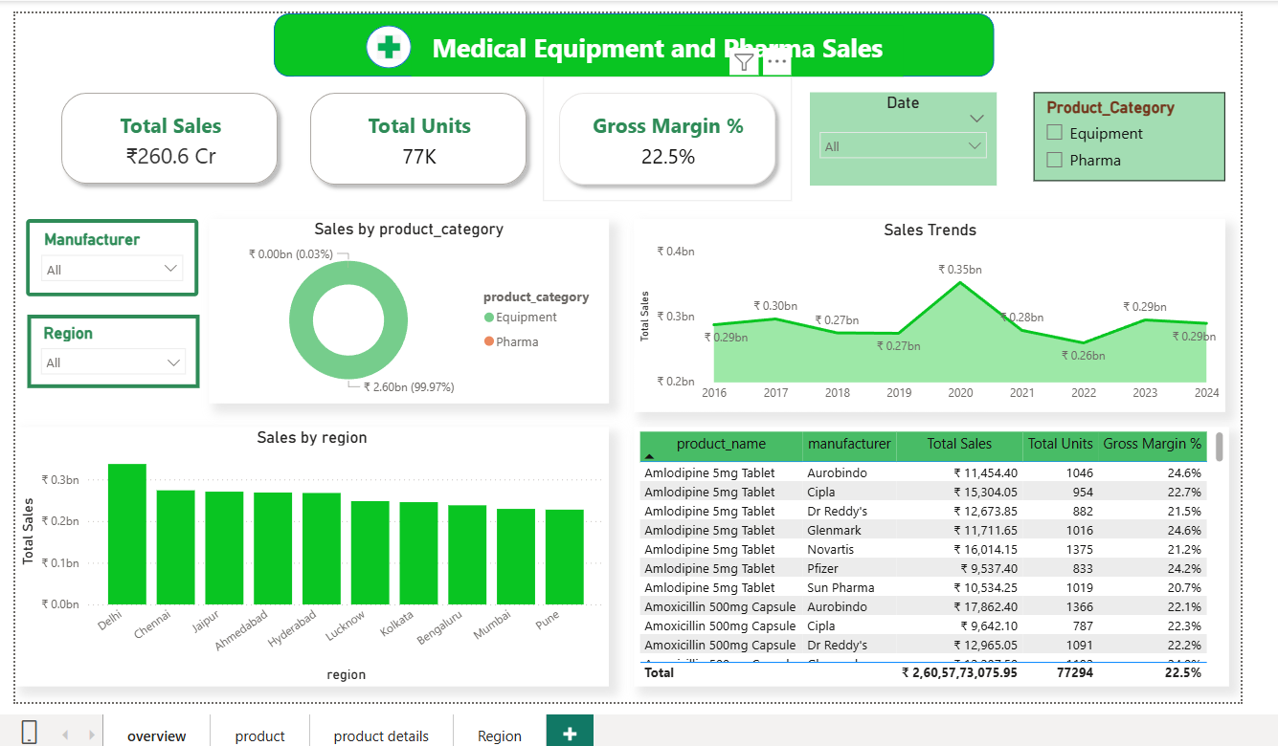

Product Deep-Dive Page:
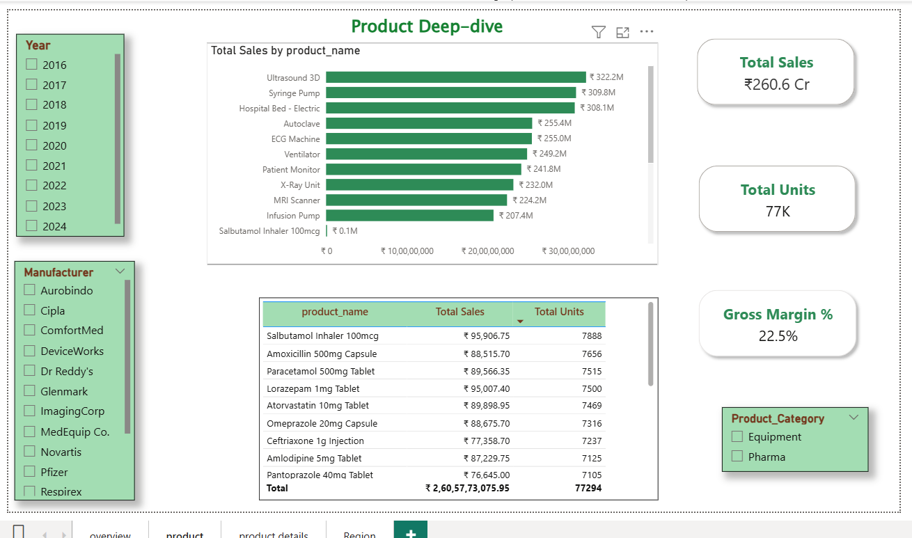

Region / Hospital Deep-Dive Page:

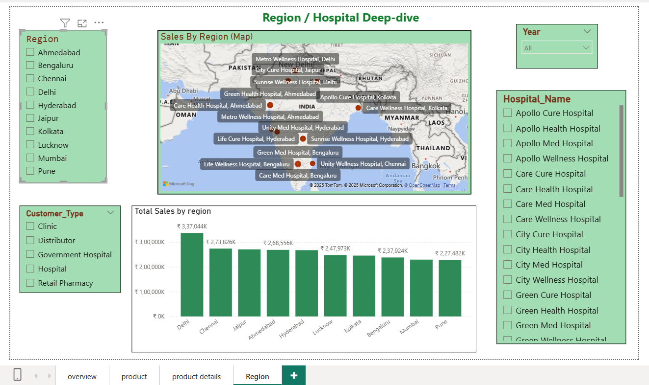

Key Findings:

• Total Sales across all regions amounted to ₹260.6 Cr with 77K total units sold and an average Gross Margin of 22.5%.
• Delhi, Chennai, and Jaipur emerged as the top-performing regions in terms of total revenue.
• Equipment category contributed to nearly all the total sales, indicating a dominant product line compared to Pharma.
• Top-selling products include Ultrasound 3D, Syringe Pump, and Hospital Bed - Electric, showing strong demand in diagnostic and patient care equipment.
• Aurobindo, Cipla, and Dr. Reddy’s were among the leading manufacturers contributing to total sales.

Recommendations:

• Focus sales efforts on high-performing regions such as Delhi and Chennai.
• Increase marketing and distributor support in lower-performing cities.
• Expand partnerships with large hospital networks to increase recurring sales.
• Implement predictive modeling in Power BI for future sales forecasting.
• Continue integrating new data for continuous performance monitoring.

Tools and Technologies:

• Tools: Power BI, Excel, GitHub.
• Version Control: Git commits were regularly updated to track project evolution.
• Challenges: Handling data joins, ensuring proper relationships, and managing DAX performance optimization.

Conclusion:

This dashboard successfully delivers actionable insights into the sales performance of the Medical Equipment and Pharma sectors. By leveraging Power BI’s interactive features, it enhances visibility across business dimensions and supports data-driven decision-making.

